

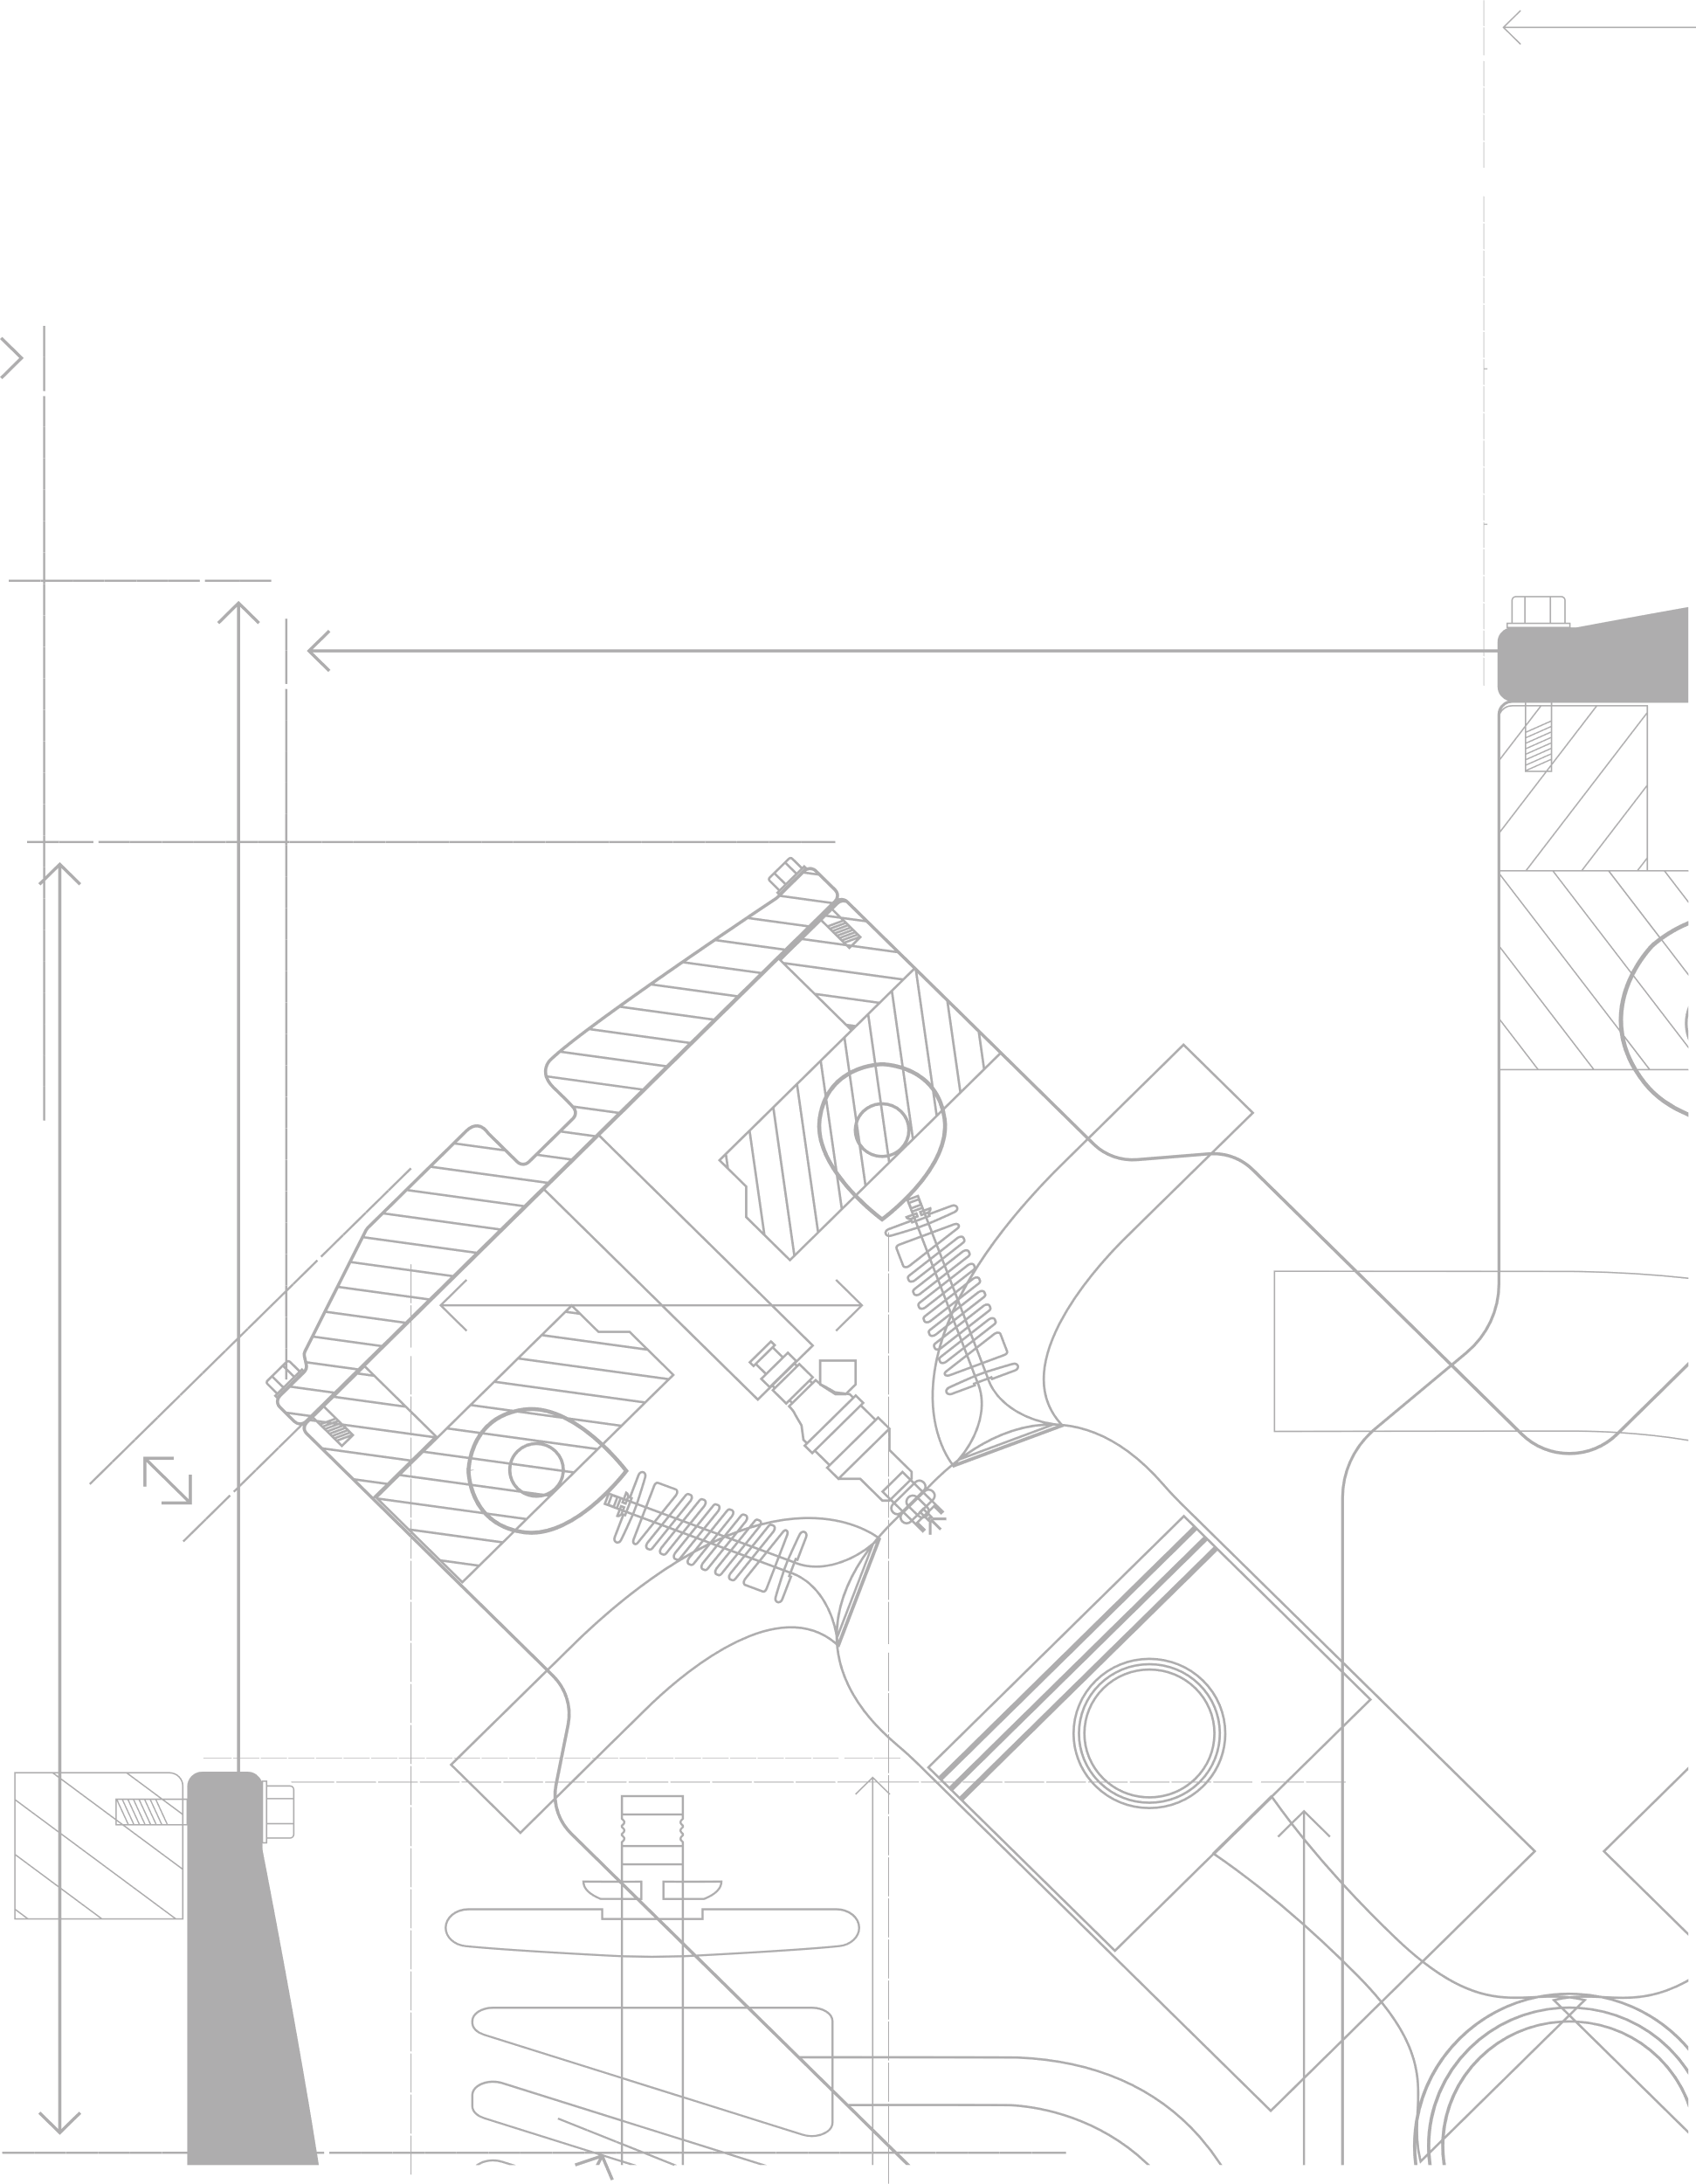



Xlscout.ai
Search Summary

Report
Disclosure Under Review
Hybrid Energy Harvesting System Using Train-Induced Vibration and Airflow in Railway Tunnels

Key Features
1. A hybrid energy harvesting system for railway and metro tunnels, configured to capture mechanical vibration and aerodynamic airflow.
2. The system comprises piezoelectric sensors to convert mechanical vibrations from passing trains into electrical energy.
3. The system comprises a micro turbine to capture kinetic energy from vehicle-induced airflow.
4. The system comprises an embedded microcontroller to regulate the energy harvested from the piezoelectric sensors and the micro turbine.
5. The system comprises a rechargeable battery for energy storage.
6. Wherein the embedded microcontroller is configured for intelligent power monitoring by tracking generated voltage and the battery's status.
7. Wherein the embedded microcontroller provides charging protection for the battery.
8. Wherein the regulated power is used to charge the rechargeable battery.
9. Wherein the system is configured for automatic energy capture to power low-energy devices, including led indicators and environmental monitoring sensors.

Key Documents Identified
Pub. Number | Assignee | Title | Key Features Mapping
US-20100060231-A1 | TPL INC | Method and Apparatus for Energy Harvesting and/or Generation, Storage, and Delivery | 1p, 2, 3p, 4p, 5, 6, 7, 8, 9p
KR-102610913-B1 | 한국전자통신연구원 | HYBRID SELF GENERATOR USING VIBRATION SOURCE AND WIND SOURCE AND WIRELESS SENSOR USING THE SAME | 1, 2, 3p, 4p, 5p, 6p, 7p, 8, 9
CN-121067299-A | JIANGSU SUNBIRD LIGHTING ELECTRICAL APPLIANCE CO LTD | Self-powered dustproof lamp for traffic tunnel and use method thereof | 1p, 2, 3p, 4p, 5, 6p, 7, 8, 9p
US-20150022005-A1 | DONNIE E JORDAN SR | Hybrid Energy Harvesting Device and Fixed Threshold Power Production | 1p, 2, 3p, 4p, 5, 6p, 7p, 8, 9p
CN-119010447-A | ZHEJIANG JIAOTOU EXPRESSWAY OPERATION MANAGEMENT CO LTD | Tunnel lightweight sensing monitoring system based on Internet of things | 1, 2, 3p, 4p, 5p, 6p, 7p, 8, 9p
WO-2023281553-A1 | UNIVERSITY OF JORDAN | A VEHICLE CHARGING STATION | 1p, 2p, 3p, 4p, 5, 6p, 7, 8, 9p
CN-202231480-U | CHINA GEOKON INSTRUMENTS CO., LTD. | Multi-power supply device of wireless Internet of things terminal | 1p, 2p, 3p, 4p, 5, 6p, 7p, 8, 9p
CN-112865272-A | ZHUZHOU CRRC TIMES ELECTRIC CO LTD | Power generation system and power generation method for multi-source railway wagon | 1p, 2p, 3p, 4p, 5, 6p, 7p, 8, 9p
IN-202521011790-A | UMESH NATHU POKHARKAR | ADVANCED MULTI-SOURCE ENERGY HARVESTING AND DISTRIBUTION SYSTEM | 1p, 2p, 3p, 4p, 5, 6p, 7p, 8, 9p
JP-2016005290-A | INDIVIDUAL | ELECTRIC VEHICLE | 1p, 2p, 3p, 4p, 5, 6p, 7, 8, 9n
IN-2015MU01572-A | PANKAJ KADAM | ENERGY HARVESTER | 1n, 2p, 3p, 4p, 5, 6p, 7, 8, 9p
IN-202511038900-A | CHANDIGARH UNIVERSITY | AI-BASED TUNNEL MANAGEMENT SYSTEM WITH LOW ENERGY CONSUMPTION | 1, 2, 3, 4p, 5p, 6p, 7n, 8p, 9p
JP-2012175766-A | UEDA BRAKE KK | VIBRATION POWER GENERATION DRIVING METHOD AND VIBRATION POWER GENERATION DRIVING DEVICE FOR TRAVELING BODY | 1p, 2, 3n, 4p, 5, 6p, 7p, 8, 9p
US-20220109385-A1 | VENTUS ENGINEERING GMBH | HYBRID ENERGY HARVESTING UNIT AND USE THEREOF | 1p, 2p, 3p, 4p, 5, 6p, 7p, 8, 9p
CN-213057050-U | CRSC RESEARCH AND DESIGN INSTITUTE GROUP CO LTD | Double-mode train tail meeting safety requirements | 1p, 2p, 3p, 4p, 5, 6p, 7p, 8, 9p

Analysis of Key Features
1. US-20100060231-A1: This document discloses a hybrid energy harvesting system utilizing piezoelectric sensors (2) and a micro turbine (3p) for energy capture, along with a rechargeable battery (5) for storage. While it covers core components and energy regulation (4p, 6, 7, 8), its application specifically within railway/metro tunnels (1p) and powering low-energy devices (9p) appears partially covered, suggesting a general rather than specific context.
2. KR-102610913-B1: This document presents a hybrid self-generator using vibration and wind sources (1, 2, 3p), which aligns closely with the disclosure's core energy capture mechanisms. It also includes a battery (5p) and regulation (4p, 6p, 7p, 8), demonstrating a comprehensive system for powering wireless sensors (9). The primary difference may lie in the specificity of the 'micro turbine' and the detailed control aspects of the microcontroller.
3. CN-121067299-A: This document describes a self-powered dustproof lamp for traffic tunnels, incorporating a hybrid energy harvesting approach (1p) with piezoelectric elements (2) and wind energy (3p). It includes a battery (5) and regulation (4p, 6p, 7, 8) to power a lamp (9p). The relevance is high due to the tunnel environment and similar energy sources, but the specific 'micro turbine' and comprehensive monitoring features might differ.
4. US-20150022005-A1: This document details a hybrid energy harvesting device with fixed threshold power production, featuring piezoelectric elements (2) and wind capture (3p), along with a battery (5) and regulation (4p, 6p, 7p, 8). While it maps many functional aspects, its specific application to railway/metro tunnels (1p) and the exact nature of the 'micro turbine' might be generalized or implied rather than explicitly detailed, similar to other documents.
5. CN-119010447-A: This document describes a tunnel lightweight sensing monitoring system based on the Internet of Things, utilizing a hybrid energy harvesting approach (1) with piezoelectric sensors (2) and wind energy (3p). It includes a battery (5p) and regulation (4p, 6p, 7p, 8) to power sensors (9p). This document is highly relevant as it explicitly addresses a tunnel environment and powering sensors, aligning closely with the disclosure's application.
6. WO-2023281553-A1: This document pertains to a vehicle charging station, which generally covers hybrid energy harvesting (1p) with vibration (2p) and wind (3p) sources, a battery (5), and regulation (4p, 6p, 7, 8). While it includes many elements, its primary focus on vehicle charging may diverge from the disclosure's application for low-energy devices (9p) in railway tunnels, making its direct relevance somewhat broader.
7. CN-202231480-U: This document describes a multi-power supply device for wireless Internet of Things terminals, featuring hybrid energy harvesting (1p) from vibration (2p) and wind (3p) sources, a battery (5), and regulation (4p, 6p, 7p, 8). It aims to power IoT terminals (9p), which aligns with the disclosure's low-energy device application. The specific context of railway tunnels might be implied rather than explicitly stated.
8. CN-112865272-A: This document discloses a power generation system and method for a multi-source railway wagon, which includes hybrid energy harvesting (1p) from vibration (2p) and wind (3p) sources, a battery (5), and regulation (4p, 6p, 7p, 8). Its railway context is highly relevant, but the application on a wagon differs from a tunnel installation, and the specific 'micro turbine' and 'piezoelectric sensors' may be broadly described (2p, 3p).
9. IN-202521011790-A: This document describes an advanced multi-source energy harvesting and distribution system, encompassing hybrid energy harvesting (1p) from vibration (2p) and wind (3p) sources, a battery (5), and regulation (4p, 6p, 7p, 8). It aims to power various devices (9p), but the specific application in railway/metro tunnels is not explicitly defined, suggesting a more general system.
10. JP-2016005290-A: This document relates to an electric vehicle, which may incorporate hybrid energy harvesting (1p) from vibration (2p) and wind (3p) sources, a battery (5), and regulation (4p, 6p, 7, 8). However, the application is on a vehicle itself, not within a railway tunnel, and the specific use for low-energy devices (9n) is missing, limiting its direct relevance to the disclosure's context.
11. IN-2015MU01572-A: This document describes an energy harvester with piezoelectric (2p) and wind (3p) components, a battery (5), and regulation (4p, 6p, 7, 8) to power devices (9p). However, it lacks the specific hybrid system for railway/metro tunnels (1n), indicating a more generic energy harvesting solution without the specialized environmental context of the disclosure.
12. IN-202511038900-A: This document describes an AI-based tunnel management system with low energy consumption, explicitly mentioning a hybrid energy harvesting system (1) with vibration (2) and airflow (3) sources. It includes a battery (5p) and regulation (4p, 6p, 8p) to power sensors (9p). The lack of explicit charging protection (7n) could be a distinguishing factor, but the overall system and application are highly similar.
13. JP-2012175766-A: This document discloses a vibration power generation driving method and device for a traveling body, utilizing vibration (2) for energy harvesting, with a battery (5) and regulation (4p, 6p, 7p, 8). It lacks the airflow component (3n) and its application is for a traveling body rather than a fixed tunnel installation, making it less directly relevant as a hybrid system for tunnels (1p).
14. US-20220109385-A1: This document describes a hybrid energy harvesting unit and its use, incorporating vibration (2p) and wind (3p) sources, a battery (5), and regulation (4p, 6p, 7p, 8). It aims to power devices (9p), but the specific context of railway/metro tunnels (1p) is not explicitly detailed, suggesting a more general hybrid harvesting solution.
15. CN-213057050-U: This document describes a double-mode train tail meeting safety requirements, which may include hybrid energy harvesting (1p) from vibration (2p) and wind (3p) sources, a battery (5), and regulation (4p, 6p, 7p, 8). Its application is on a train rather than within a tunnel, and the specific use for low-energy devices (9p) is present but within a different context.

Novelty and obviousness analysis
The disclosure's novelty faces significant challenges from multiple documents. Specifically, KR-102610913-B1 and CN-119010447-A disclose hybrid self-generators utilizing both vibration and wind/airflow sources in relevant contexts (general or traffic tunnels), including piezoelectric sensors, micro turbines/wind capture, batteries, and regulation for powering low-energy devices. IN-202511038900-A is particularly strong, explicitly detailing an AI-based tunnel management system with low energy consumption, utilizing hybrid energy harvesting (vibration and airflow) in a tunnel, comprising piezoelectric sensors, micro turbines, a battery, and regulation for powering sensors. While some documents may partially map specific microcontroller features like 'charging protection for the battery' (7), the overall combination of features for a hybrid energy harvesting system in a tunnel environment to power low-energy devices appears to be anticipated by at least IN-202511038900-A, which maps nearly all key features. Therefore, the disclosure as a whole may lack novelty over this document. Furthermore, even if not fully anticipated by a single document, the disclosure would likely be considered obvious to a person skilled in the art, given the commonality of hybrid vibration/wind harvesting, battery storage, and microcontroller-based regulation for low-power applications in tunnel or railway environments, as evidenced by documents like US-20100060231-A1, CN-121067299-A, and CN-119010447-A. The patentability assessment suggests that the disclosure faces substantial novelty and inventive step challenges due to the breadth and specificity of the prior art.

Potential Risks and Opportunities
The primary risk to novelty lies in the combination of hybrid energy harvesting (vibration and airflow) in a tunnel environment for powering low-energy devices, as this combination is well-represented in the prior art, particularly by IN-202511038900-A. Opportunities for potential novelty may reside in the specific implementation details of the 'micro turbine' for vehicle-induced airflow, the precise configuration and sensitivity of the 'piezoelectric sensors' for train-induced vibration, or the advanced functionalities of the 'embedded microcontroller' beyond standard power monitoring and charging protection, such as specific intelligent power management algorithms tailored to the unique energy profiles of railway tunnels.

Recommendations
Prioritize a detailed legal and technical review of IN-202511038900-A, KR-102610913-B1, and CN-119010447-A to identify any subtle differences in the specific types of sensors, turbines, or microcontroller logic that might distinguish the disclosure.
Refine the claims to emphasize the unique aspects of the 'micro turbine' design optimized for vehicle-induced airflow in tunnels, the specific characteristics of the 'piezoelectric sensors' for train-induced vibration, or any novel intelligent power management algorithms implemented by the 'embedded microcontroller' that go beyond generic regulation and protection.

Reviewer Notes
The mapping indicates strong overlap in the core concept of hybrid vibration and airflow energy harvesting within a tunnel context. The term 'micro turbine' for airflow capture is common, as are piezoelectric sensors for vibration. The 'embedded microcontroller' performing regulation, monitoring, and charging protection is also a standard component in such systems. Future claim drafting should focus on highly specific structural or algorithmic details of the components, particularly the energy capture mechanisms and the microcontroller's intelligent functionalities, rather than the general system architecture, to improve patentability prospects. Clarification on the 'AI-assisted analysis' mentioned in the prompt, if it refers to the disclosure's features, could also be an area for differentiation if not explicitly mapped.
Reviewed By
Name:
Date: | 2026-02-11
Signature:

Disclaimer
This report has been generated by AI. While efforts have been made to ensure accuracy and relevance, the content should not be considered a substitute for professional judgment. Users are strongly encouraged to conduct an independent manual review of the cited prior art and analysis before making any legal, technical, or strategic decisions. XLSCOUT and its affiliates disclaim any liability arising from the use of this report without such independent verification.

